

**SIMATS SCHOOL OF ENGINEERING**

**SAVEETHA INSTITUTE OF MEDICAL AND TECHNICAL SCIENCES**

**CHENNAI-602105**

Library Management System

**A CAPSTONE PROJECT REPORT**

*Submitted in the partial fulfillment for the award of the degree of*

**BACHELOR OF ENGINEERING**

**IN**

**Computer Science and Engineering**

**Submitted by**

**P. Keerthananjani (192211832)**

**V. Sai Monika (192211839)**

**Under the Supervision of**

**K. Vivek Balaji**

**JULY 2024**

**DECLARATION**

We, **P. Keerthananjani, V. Sai Monika** students of **Bachelor of Engineering**, Department of Computer Science, Saveetha Institute of Medical and Technical Sciences, Saveetha University, Chennai, hereby declare that the work presented in this Capstone Project Work entitled **Library Management System** is the outcome of our own bonafide work and is correct to the best of our knowledge and this work has been undertaken taking care of Engineering Ethics.

P. Keerthananjani (192211832)

V. Sai Monika (192211839)

Date:

Place:

**CERTIFICATE**

This is to certify that the project entitled **“Library Management System Using Java for Web Development”** submitted by **P. Keerthananjani and V. Sai Monika** has been carried out under my supervision. The project has been submitted as per the requirements in the current semester of B. Tech Computer Science Engineering.

Teacher-in-charge

Vivek Balaji.

**Table of Contents**

|  |  |
| --- | --- |
| **S.NO** | **TOPICS** |
| **1** | **Abstract** |
| **2** | **Introduction** |
| **3** | **Objective of project** |
| **4** | **Literature Survey** |
| **5** | **Tool Description** |
| **6** | **Flow Charts** |
| **7** | **Code & Implementation** |
| **8** | **Presentation-** Output |
| **9** | **Conclusion** |
| **10** | **References** |

**1.Abstract:**

This project presents the development of a Library Management System (LMS) using Java, designed to streamline and automate the management of library resources and user activities. The system incorporates a MySQL database to store comprehensive information about books, users, and loans. The backend logic is implemented in Java, utilizing model classes to represent library entities, Data Access Object (DAO) classes to handle database interactions, and service classes to encapsulate business logic. The user interface is developed using JavaFX.

providing an intuitive and interactive experience for librarians and users. Key functionalities of the LMS include user authentication, book management (addition, removal, and search), user management (registration and profile management), and loan management (issue and return of books). The project aims to demonstrate the integration of database operations with a robust backend and a user-friendly frontend, offering a scalable and efficient solution for library management. This system enhances the efficiency of library operations, reduces manual efforts, and ensures accurate record-keeping, thereby improving the overall user experience and resource utilization in libraries.

**2.INTRODUCTION:**

Libraries play a crucial role in the dissemination of knowledge and information, serving as vital resources for students, researchers, and the general public. Traditionally, the management of library resources, including books, users, and loan records, has been a labor-intensive process prone to human error. The advent of digital technologies presents an opportunity to streamline these processes, enhancing efficiency and accuracy. This project aims to address these challenges by developing a Library Management System (LMS) using Java. The primary objective of this LMS is to automate the key functions of a library, including cataloging boo

ks, managing user information, tracking book loans, and generating reports. By leveraging the capabilities of Java for backend development and JavaFX for the user interface, the system provides a robust and user-friendly solution.

**3. Objectives of project:**

The Library Management System (LMS) project is a comprehensive software solution designed to streamline and automate the management of library resources. This project addresses the inefficiencies and challenges associated with traditional library management by providing a robust, scalable, and user-friendly system built using Java and JavaFX. The system integrates with a MySQL database to ensure efficient storage and retrieval of data related to books, users, and loans.

Libraries often face challenges in efficiently managing their resources and providing seamless services to their users. Traditional methods of managing book catalogs, user records, and loan transactions involve significant manual effort, leading to inefficiencies and errors. A robust and automated system can alleviate these issues by streamlining library operations, ensuring accurate record-keeping, and enhancing user experience.

**4. Literature review:**

Implementation Overview

1. **Database Schema**:
   * Tables: Users, Books, Loans, etc.
   * Relationships: Foreign keys to link users and books with loan records.
2. **Backend Components**:
   * **Model Classes**: Represent entities such as Book, User, and Loan.
   * **DAO Classes**: Handle database operations (CRUD) for each entity.
   * **Service Classes**: Contain business logic and coordinate between DAOs and the frontend.
3. **Frontend Components**:
   * **JavaFX Application**: Provides a user interface for interacting with the system.
   * **Forms and Tables**: For data entry and display (e.g., book catalog, user profiles).
   * **Interactive Elements**: Buttons, search fields, and notifications for user actions.

**5. TOOL DESCRPTION:**

The Library Management System (LMS) is a software tool developed to manage library operations efficiently. This tool leverages Java for backend processing, JavaFX for the graphical user interface, and MySQL for database management. It provides a comprehensive solution for managing books, users, and loans, facilitating smooth library operations.

The approach involves dividing the system into multiple modules, each responsible for a specific set of functionalities. Each module will have individual functions to handle various operations, and these functions will be unified to form the complete software system. The modules include:

* **Book Management Module**: Handles operations related to book management.
* **User Management Module**: Handles operations related to user management.
* **Student Management Module**: Handles operations related to student management.

### User Interface

The user interface of the LMS is designed using JavaFX, which provides a modern and responsive graphical user interface (GUI). The UI is intuitive, allowing librarians and patrons to interact with the system seamlessly. Key components of the UI include:

1. **Main Dashboard**: The starting point for all users, displaying an overview of library operations and navigation options.
2. **Book Management**: Interfaces for adding, updating, and viewing books in the library catalog.
3. **User Management**: Interfaces for registering new users and managing existing user profiles.
4. **Loan Management**: Interfaces for issuing and returning books, and viewing loan history.
5. **Reports and Analytics**: Screens for generating and viewing various reports on library usage and statistics.

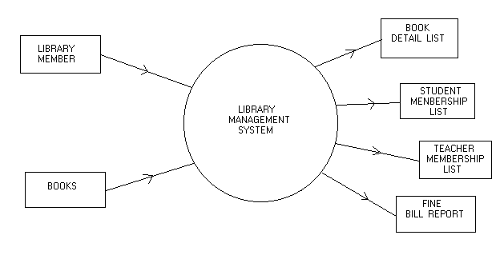**6**. **Flow Charts:**

**7. Code and Implementation:**

**Login Page Module:**

<?php

    session_start();

?>

<!DOCTYPE html>

<html>

<head>

    <title>Library Management System</title>

    <meta charset="utf-8" name="viewport" content="width=device-width,intial-scale=1">

    <link rel="stylesheet" type="text/css" href="bootstrap-4.4.1/css/bootstrap.min.css">

      <script type="text/javascript" src="bootstrap-4.4.1/js/juqery_latest.js"></script>

      <script type="text/javascript" src="bootstrap-4.4.1/js/bootstrap.min.js"></script>

</head>

<style type="text/css">

    #main_content{

        background: rgba(245, 245, 245, 0.9);

        padding: 50px;

    }

    #side_bar{

        background: rgba(245, 245, 245, 0.9);

        padding: 50px;

    }

    body{

      background: rgba(245, 245, 245, 0.4);

      background-image: url("https://img.freepik.com/free-photo/abundant-collection-antique-books-wooden-shelves-generated-by-ai_188544-29660.jpg?size=626&amp;ext=jpg&amp;ga=GA1.1.1546980028.1704240000&amp;semt=sph");

   }

</style>

<body>

    <nav class="navbar navbar-expand-lg navbar-dark bg-dark">

        <div class="container-fluid">

            <div class="navbar-header">

                <a class="navbar-brand" href="index.php">Library Management System</a>

            </div>

            <ul class="nav navbar-nav navbar-right">

                <li class="nav-item">

                  <a class="nav-link" href="index.php">User Login</a>

                </li>

              <li class="nav-item">

                <a class="nav-link" href="admin/indexad.php">Admin Login</a>

              </li>

              <li class="nav-item">

                <a class="nav-link" href="signup.php"></span>Signup</a>

              </li>

            </ul>

        </div>

    </nav>

    <div class="row">

        <div class="col-md-4" id="side_bar">

            <h5>Today's Quote</h5>

            <h6>“There is more treasure in books than in all the pirate's loot on Treasure Island"</h6>

            <p>~ Walt Disney</p>

            <h5>Library Timing</h5>

            <ul>

                <li>Opening: 9:00 AM</li>

                <li>Closing: 12:00 PM</li>

            </ul>

            <h5>What We provide ?</h5>

            <ul>

                <li>AC Rooms</li>

                <li>Free Wi-fi</li>

                <li>Learning Environment</li>

                <li>Discussion Room</li>

                <li>Free Electricity</li>

            </ul>

        </div>

        <div class="col-md-8" id="main_content">

            <center><h3>User Login Form</h3></center>

            <form action="" method="post">

                <div class="form-group">

                    <label for="email">Email ID:</label>

                    <input type="text" name="email" class="form-control" required>

                </div>

                <div class="form-group">

                    <label for="password">Password:</label>

                    <input type="password" name="password" class="form-control" required>

                </div>

                <button type="submit" name="login" class="btn btn-primary">Login</button> |

                <a href="signup.php"> Signup now !!</a>

            </form>

            <?php

                if(isset($_POST['login'])){

                    $connection = mysqli_connect("localhost","root","");

                    $db = mysqli_select_db($connection,"lms");

                    $query = "select * from users where email = '$_POST[email]'";

                    $query_run = mysqli_query($connection,$query);

                    while ($row = mysqli_fetch_assoc($query_run)) {

                        if($row['email'] == $_POST['email']){

                            if($row['password'] == $_POST['password']){

                                $_SESSION['name'] =  $row['name'];

                                $_SESSION['email'] =  $row['email'];

                                $_SESSION['id'] =  $row['id'];

                                header("Location: user_dashboard.php");

                            }

                            else{

                                ?>

                                <br><br><center><span class="alert-danger">Wrong Password !!</span></center>

                                <?php

                            }

                        }

                    }

                }

            ?>

        </div>

    </div>

</body>

</html>

**OUTPUT:**

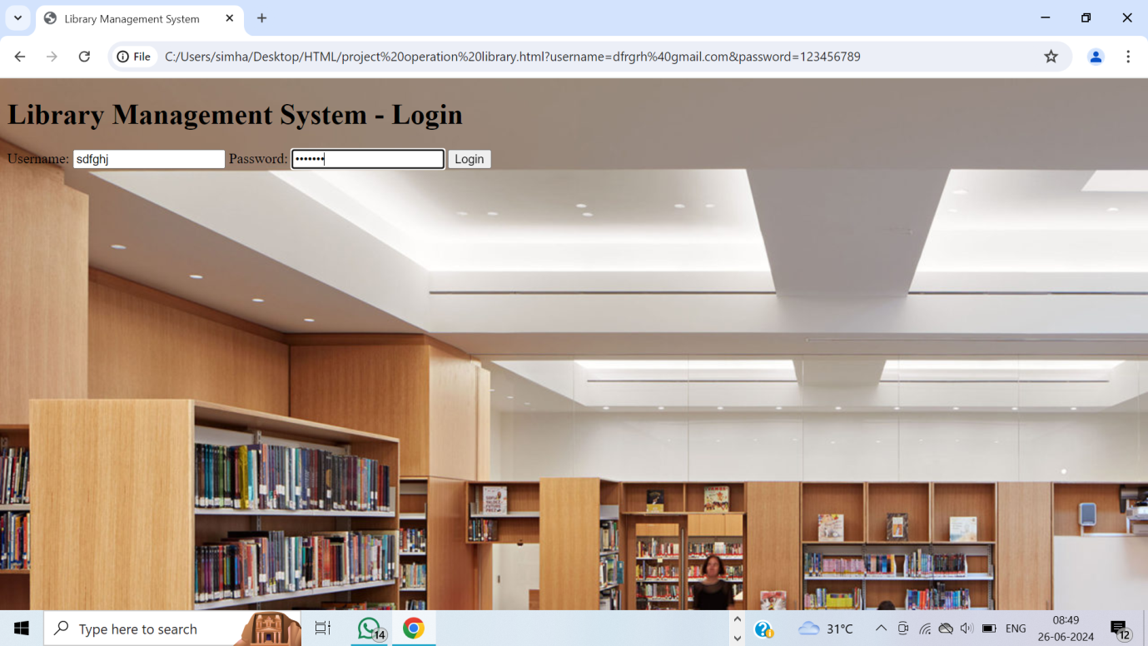

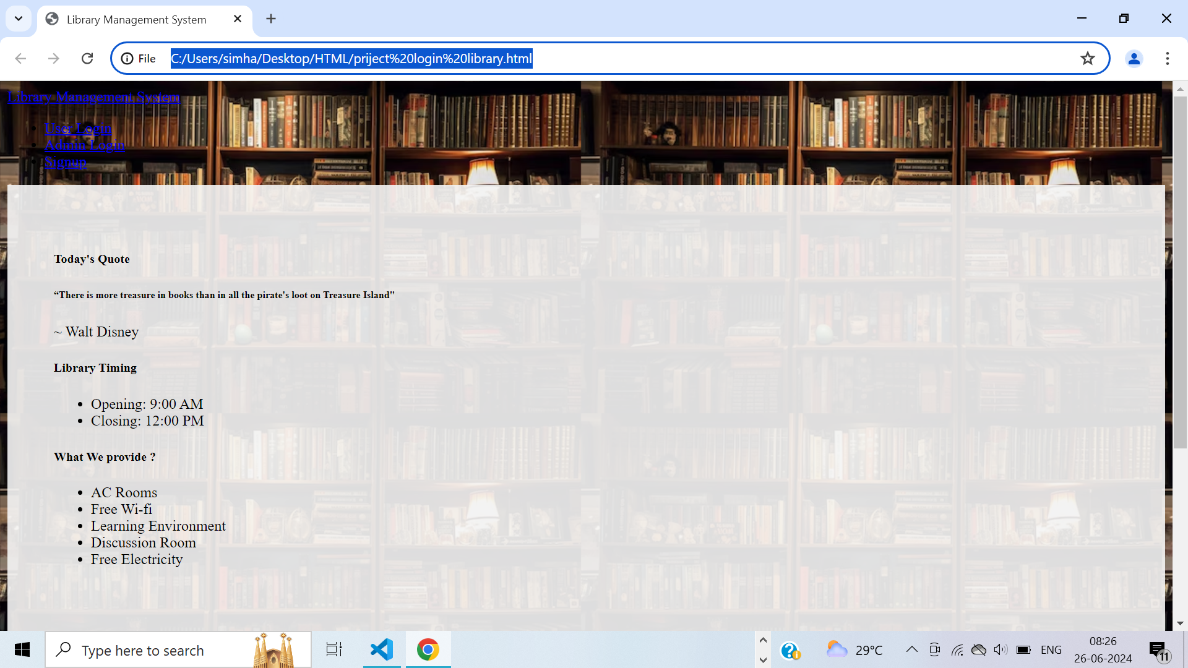

**Admin Dash Board Module:**

<?php

    require("functions.php");

    session_start();

?>

<!DOCTYPE html>

<html>

<head>

    <title>Dashboard</title>

    <meta charset="utf-8" name="viewport" content="width=device-width,intial-scale=1">

    <link rel="stylesheet" type="text/css" href="../bootstrap-4.4.1/css/bootstrap.min.css">

      <script type="text/javascript" src="../bootstrap-4.4.1/js/juqery_latest.js"></script>

      <script type="text/javascript" src="../bootstrap-4.4.1/js/bootstrap.min.js"></script>

</head>

<body>

    <nav class="navbar navbar-expand-lg navbar-dark bg-dark">

        <div class="container-fluid">

            <div class="navbar-header">

                <a class="navbar-brand" href="admin_dashboard.php">Library Management System (LMS)</a>

            </div>

            <font style="color: white"><span><strong>Welcome: <?php echo $_SESSION['name'];?></strong></span></font>

            <font style="color: white"><span><strong>Email: <?php echo $_SESSION['email'];?></strong></font>

            <ul class="nav navbar-nav navbar-right">

              <li class="nav-item dropdown">

                <a class="nav-link dropdown-toggle" data-toggle="dropdown">My Profile </a>

                <div class="dropdown-menu">

                    <a class="dropdown-item" href="view_profile.php">View Profile</a>

                    <div class="dropdown-divider"></div>

                    <a class="dropdown-item" href="edit_profile.php">Edit Profile</a>

                    <div class="dropdown-divider"></div>

                    <a class="dropdown-item" href="change_password.php">Change Password</a>

                </div>

              </li>

              <li class="nav-item">

                <a class="nav-link" href="../logout.php">Logout</a>

              </li>

            </ul>

        </div>

    </nav><br>

    <nav class="navbar navbar-expand-lg navbar-light" style="background-color: #e3f2fd">

        <div class="container-fluid">

            <ul class="nav navbar-nav navbar-center">

              <li class="nav-item">

                <a class="nav-link" href="admin_dashboard.php">Dashboard</a>

              </li>

              <li class="nav-item dropdown">

                <a class="nav-link dropdown-toggle" data-toggle="dropdown">Books </a>

                <div class="dropdown-menu">

                    <a class="dropdown-item" href="add_book.php">Add New Book</a>

                    <div class="dropdown-divider"></div>

                    <a class="dropdown-item" href="manage_book.php">Manage Books</a>

                </div>

              </li>

              <li class="nav-item dropdown">

                <a class="nav-link dropdown-toggle" data-toggle="dropdown">Category </a>

                <div class="dropdown-menu">

                    <a class="dropdown-item" href="add_cat.php">Add New Category</a>

                    <div class="dropdown-divider"></div>

                    <a class="dropdown-item" href="manage_cat.php">Manage Category</a>

                </div>

              </li>

              <li class="nav-item dropdown">

                <a class="nav-link dropdown-toggle" data-toggle="dropdown">Authors</a>

                <div class="dropdown-menu">

                    <a class="dropdown-item" href="add_author.php">Add New Author</a>

                    <div class="dropdown-divider"></div>

                    <a class="dropdown-item" href="manage_author.php">Manage Author</a>

                </div>

              </li>

              <li class="nav-item">

                <a class="nav-link" href="issue_book.php">Issue Book</a>

              </li>

            </ul>

        </div>

    </nav><br>

    <div class="row">

        <div class="col-md-3" style="margin: 0px ">

            <div class="card bg-light" style=" width: 300px ">

                <div class="card-header">Registered User</div>

                <div class="card-body">

                    <p class="card-text">No. total Users: <?php echo get_user_count();?></p>

                    <a class="btn btn-danger" href="Regusers.php" target="_blank">View Registered Users</a>

                </div>

            </div>

        </div>

        <div class="col-md-3" style="margin: 0px">

            <div class="card bg-light" style="width: 300px">

                <div class="card-header">Total Book</div>

                <div class="card-body">

                    <p class="card-text">No of books available: <?php echo get_book_count();?></p>

                    <a class="btn btn-success" href="Regbooks.php" target="_blank">View All Books</a>

                </div>

            </div>

        </div>

        <div class="col-md-3" style="margin: 0px">

            <div class="card bg-light" style="width: 300px">

                <div class="card-header">Book Categories</div>

                <div class="card-body">

                    <p class="card-text">No of Book's Categories: <?php echo get_category_count();?></p>

                    <a class="btn btn-warning" href="Regcat.php" target="_blank">View Categories</a>

                </div>

            </div>

        </div>

        <div class="col-md-3" style="margin: 0px">

            <div class="card bg-light" style="width: 300px">

                <div class="card-header">No. of Authors</div>

                <div class="card-body">

                    <p class="card-text">No of Authors: <?php echo get_author_count();?></p>

                    <a class="btn btn-primary" href="Regauthor.php" target="_blank">View Authors</a>

                </div>

            </div>

        </div>

    </div><br><br>

    <div class="row">

        <div class="col-md-3" style="margin: 0px">

            <div class="card bg-light" style="width: 300px">

                <div class="card-header">Book Issued</div>

                <div class="card-body">

                    <p class="card-text">No of book issued: <?php echo get_issue_book_count();?></p>

                    <a class="btn btn-success" href="view_issued_book.php" target="_blank">View Issued Books</a>

                </div>

            </div>

        </div>

        <div class="col-md-3"></div>

        <div class="col-md-3"></div>

    </div>

</body>

</html>

**OUTPUT:**

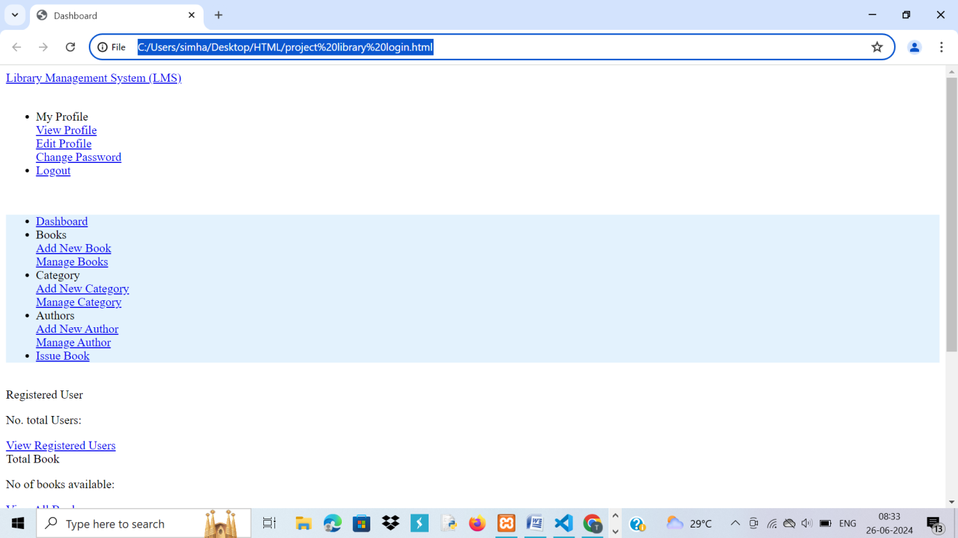

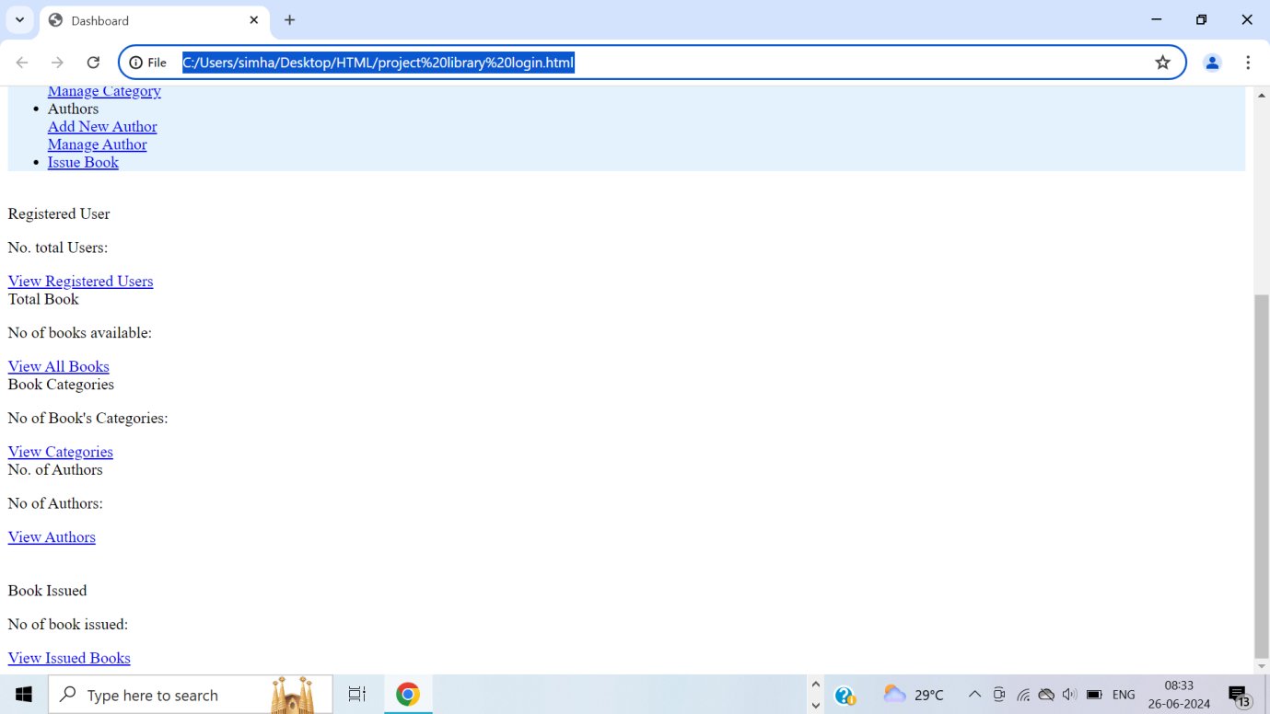

**ADD or Catagorize:**

<?php

    require("functions.php");

    session_start();

    #fetch data from database

    $connection = mysqli_connect("localhost","root","");

    $db = mysqli_select_db($connection,"lms");

    $name = "";

    $email = "";

    $mobile = "";

    $query = "select * from admins where email = '$_SESSION[email]'";

    $query_run = mysqli_query($connection,$query);

    while ($row = mysqli_fetch_assoc($query_run)){

        $name = $row['name'];

        $email = $row['email'];

        $mobile = $row['mobile'];

    }

?>

<!DOCTYPE html>

<html>

<head>

    <title>Add New Book</title>

    <meta charset="utf-8" name="viewport" content="width=device-width,intial-scale=1">

    <link rel="stylesheet" type="text/css" href="../bootstrap-4.4.1/css/bootstrap.min.css">

      <script type="text/javascript" src="../bootstrap-4.4.1/js/juqery_latest.js"></script>

      <script type="text/javascript" src="../bootstrap-4.4.1/js/bootstrap.min.js"></script>

      <script type="text/javascript">

          function alertMsg(){

              alert(Book added successfully...);

              window.location.href = "admin_dashboard.php";

          }

      </script>

</head>

<body>

    <nav class="navbar navbar-expand-lg navbar-dark bg-dark">

        <div class="container-fluid">

            <div class="navbar-header">

                <a class="navbar-brand" href="admin_dashboard.php">Library Management System (LMS)</a>

            </div>

            <font style="color: white"><span><strong>Welcome: <?php echo $_SESSION['name'];?></strong></span></font>

            <font style="color: white"><span><strong>Email: <?php echo $_SESSION['email'];?></strong></font>

            <ul class="nav navbar-nav navbar-right">

              <li class="nav-item dropdown">

                <a class="nav-link dropdown-toggle" data-toggle="dropdown">My Profile </a>

                <div class="dropdown-menu">

                    <a class="dropdown-item" href="">View Profile</a>

                    <div class="dropdown-divider"></div>

                    <a class="dropdown-item" href="#">Edit Profile</a>

                    <div class="dropdown-divider"></div>

                    <a class="dropdown-item" href="change_password.php">Change Password</a>

                </div>

              </li>

              <li class="nav-item">

                <a class="nav-link" href="../logout.php">Logout</a>

              </li>

            </ul>

        </div>

    </nav><br>

    <nav class="navbar navbar-expand-lg navbar-light" style="background-color: #e3f2fd">

        <div class="container-fluid">

            <ul class="nav navbar-nav navbar-center">

              <li class="nav-item">

                <a class="nav-link" href="admin_dashboard.php">Dashboard</a>

              </li>

              <li class="nav-item dropdown">

                <a class="nav-link dropdown-toggle" data-toggle="dropdown">Books </a>

                <div class="dropdown-menu">

                    <a class="dropdown-item" href="add_book.php">Add New Book</a>

                    <div class="dropdown-divider"></div>

                    <a class="dropdown-item" href="manage_book.php">Manage Books</a>

                </div>

              </li>

              <li class="nav-item dropdown">

                <a class="nav-link dropdown-toggle" data-toggle="dropdown">Category </a>

                <div class="dropdown-menu">

                    <a class="dropdown-item" href="add_cat.php">Add New Category</a>

                    <div class="dropdown-divider"></div>

                    <a class="dropdown-item" href="manage_cat.php">Manage Category</a>

                </div>

              </li>

              <li class="nav-item dropdown">

                <a class="nav-link dropdown-toggle" data-toggle="dropdown">Authors</a>

                <div class="dropdown-menu">

                    <a class="dropdown-item" href="add_author.php">Add New Author</a>

                    <div class="dropdown-divider"></div>

                    <a class="dropdown-item" href="manage_author.php">Manage Author</a>

                </div>

              </li>

              <li class="nav-item">

                <a class="nav-link" href="issue_book.php">Issue Book</a>

              </li>

            </ul>

        </div>

    </nav><br>

    <center><h4>Add a new Book</h4><br></center>

        <div class="row">

            <div class="col-md-4"></div>

            <div class="col-md-4">

                <form action="" method="post">

                    <div class="form-group">

                        <label for="email">Book Name:</label>

                        <input type="text" name="book_name" class="form-control" required>

                    </div>

                    <div class="form-group">

                        <label for="mobile">Author ID:</label>

                        <input type="text" name="book_author" class="form-control" required>

                    </div>

                    <div class="form-group">

                        <label for="mobile">Category ID:</label>

                        <input type="text" name="book_category" class="form-control" required>

                    </div>

                    <div class="form-group">

                        <label for="mobile">Book Number:</label>

                        <input type="text" name="book_no" class="form-control" required>

                    </div>

                    <div class="form-group">

                        <label for="mobile">Book Price:</label>

                        <input type="text" name="book_price" class="form-control" required>

                    </div>

                    <button type="submit" name="add_book" class="btn btn-primary">Add Book</button>

                </form>

            </div>

            <div class="col-md-4"></div>

        </div>

</body>

</html>

<?php

    if(isset($_POST['add_book']))

    {

        $connection = mysqli_connect("localhost","root","");

        $db = mysqli_select_db($connection,"lms");

        $query = "insert into books values(null,'$_POST[book_name]','$_POST[book_author]','$_POST[book_category]',$_POST[book_no],$_POST[book_price])";

        $query_run = mysqli_query($connection,$query);

        #header("location:add_book.php");

    }

?>

**OUTPUT:**

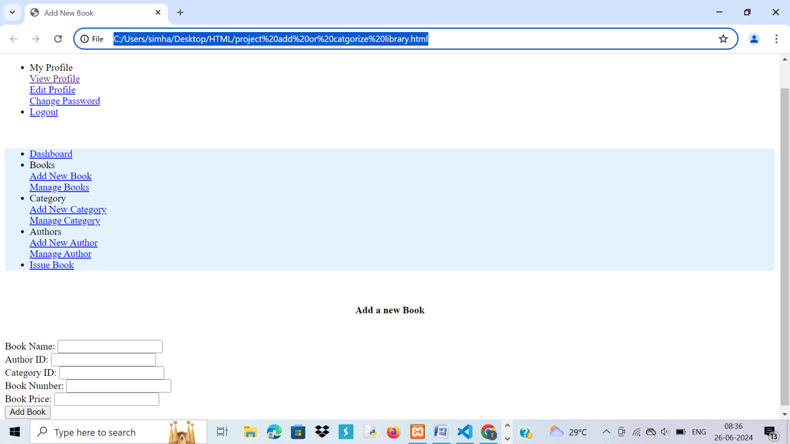

**ISSUE A BOOK:**

<?php

    session_start();

?>

<!DOCTYPE html>

<html>

<head>

    <title>Issue Book</title>

    <meta charset="utf-8" name="viewport" content="width=device-width,intial-scale=1">

    <link rel="stylesheet" type="text/css" href="../bootstrap-4.4.1/css/bootstrap.min.css">

      <script type="text/javascript" src="../bootstrap-4.4.1/js/juqery_latest.js"></script>

      <script type="text/javascript" src="../bootstrap-4.4.1/js/bootstrap.min.js"></script>

      <script type="text/javascript">

          function alertMsg(){

              alert(Book added successfully...);

              window.location.href = "admin_dashboard.php";

          }

      </script>

</head>

<body>

    <nav class="navbar navbar-expand-lg navbar-dark bg-dark">

        <div class="container-fluid">

            <div class="navbar-header">

                <a class="navbar-brand" href="admin_dashboard.php">Library Management System (LMS)</a>

            </div>

            <font style="color: white"><span><strong>Welcome: <?php echo $_SESSION['name'];?></strong></span></font>

            <font style="color: white"><span><strong>Email: <?php echo $_SESSION['email'];?></strong></font>

            <ul class="nav navbar-nav navbar-right">

              <li class="nav-item dropdown">

                <a class="nav-link dropdown-toggle" data-toggle="dropdown">My Profile </a>

                <div class="dropdown-menu">

                    <a class="dropdown-item" href="">View Profile</a>

                    <div class="dropdown-divider"></div>

                    <a class="dropdown-item" href="#">Edit Profile</a>

                    <div class="dropdown-divider"></div>

                    <a class="dropdown-item" href="change_password.php">Change Password</a>

                </div>

              </li>

              <li class="nav-item">

                <a class="nav-link" href="../logout.php">Logout</a>

              </li>

            </ul>

        </div>

    </nav><br>

    <nav class="navbar navbar-expand-lg navbar-light" style="background-color: #e3f2fd">

        <div class="container-fluid">

            <ul class="nav navbar-nav navbar-center">

              <li class="nav-item">

                <a class="nav-link" href="admin_dashboard.php">Dashboard</a>

              </li>

              <li class="nav-item dropdown">

                <a class="nav-link dropdown-toggle" data-toggle="dropdown">Books </a>

                <div class="dropdown-menu">

                    <a class="dropdown-item" href="add_book.php">Add New Book</a>

                    <div class="dropdown-divider"></div>

                    <a class="dropdown-item" href="manage_book.php">Manage Books</a>

                </div>

              </li>

              <li class="nav-item dropdown">

                <a class="nav-link dropdown-toggle" data-toggle="dropdown">Category </a>

                <div class="dropdown-menu">

                    <a class="dropdown-item" href="add_cat.php">Add New Category</a>

                    <div class="dropdown-divider"></div>

                    <a class="dropdown-item" href="manage_cat.php">Manage Category</a>

                </div>

              </li>

              <li class="nav-item dropdown">

                <a class="nav-link dropdown-toggle" data-toggle="dropdown">Authors</a>

                <div class="dropdown-menu">

                    <a class="dropdown-item" href="add_author.php">Add New Author</a>

                    <div class="dropdown-divider"></div>

                    <a class="dropdown-item" href="manage_author.php">Manage Author</a>

                </div>

              </li>

              <li class="nav-item">

                <a class="nav-link" href="issue_book.php">Issue Book</a>

              </li>

            </ul>

        </div>

    </nav><br>

    <center><h4>Issue Book</h4><br></center>

        <div class="row">

            <div class="col-md-4"></div>

            <div class="col-md-4">

                <form action="" method="post">

                    <div class="form-group">

                        <label for="book_name">Book Name:</label>

                        <input type="text" name="book_name" class="form-control" required>

                    </div>

                    <div class="form-group">

                        <label for="book_author">Author ID:</label>

                        <select class="form-control" name="book_author">

                            <option>-Select author-</option>

                            <?php

                                $connection = mysqli_connect("localhost","root","");

                                $db = mysqli_select_db($connection,"lms");

                                $query = "select author_name from authors";

                                $query_run = mysqli_query($connection,$query);

                                while($row = mysqli_fetch_assoc($query_run)){

                                    ?>

                                    <option><?php echo $row['author_name'];?></option>

                                    <?php

                                }

                            ?>

                        </select>

                        <!--<input type="text" name="book_author" class="form-control" required> -->

                    </div>

                    <div class="form-group">

                        <label for="book_no">Book Number:</label>

                        <input type="text" name="book_no" class="form-control" required>

                    </div>

                    <div class="form-group">

                        <label for="student_id">Student ID:</label>

                        <input type="text" name="student_id" class="form-control" required>

                    </div>

                    <div class="form-group">

                        <label for="issue_date">Issue Date:</label>

                        <input type="text" name="issue_date" class="form-control" value="<?php echo date("yy-m-d");?>" required>

                    </div>

                    <button type="submit" name="issue_book" class="btn btn-primary">Issue Book</button>

                </form>

            </div>

            <div class="col-md-4"></div>

        </div>

</body>

</html>

<?php

    if(isset($_POST['issue_book']))

    {

        $connection = mysqli_connect("localhost","root","");

        $db = mysqli_select_db($connection,"lms");

        $query = "insert into issued_books values(null,$_POST[book_no],'$_POST[book_name]','$_POST[book_author]',$_POST[student_id],1,'$_POST[issue_date]')";

        $query_run = mysqli_query($connection,$query);

        #header("Location:admin_dashboard.php");

    }

    ?>

**OUTPUT:**

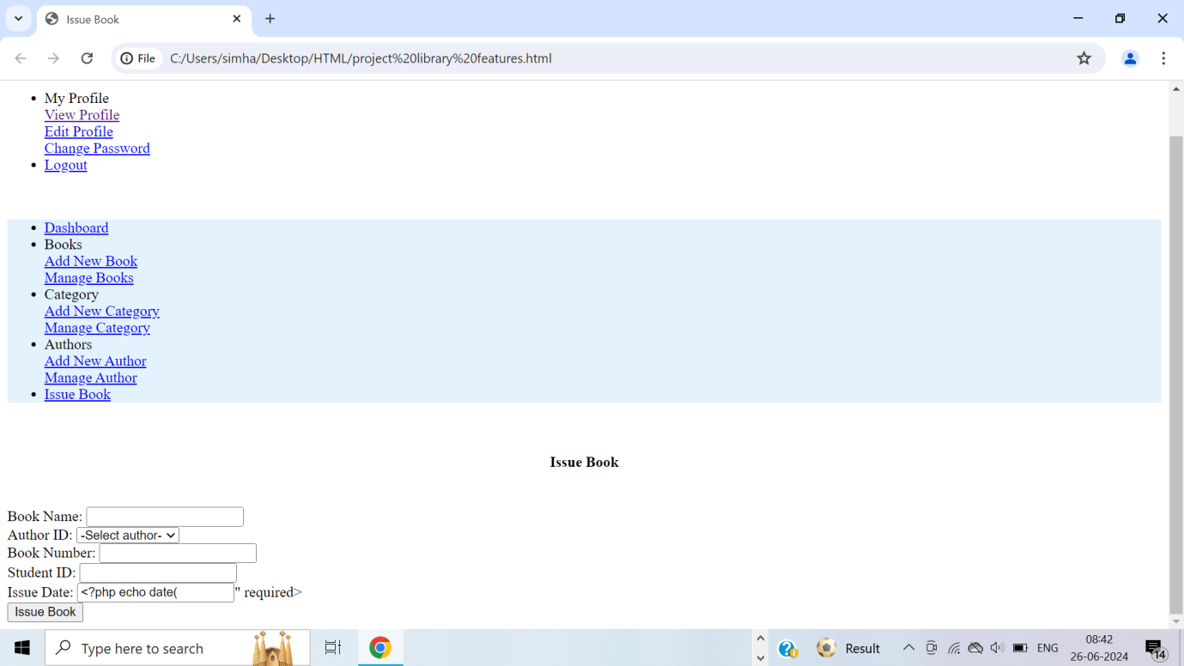

**9.CONCLUSION:**

In conclusion, this Java-based Library Management System offers a comprehensive and user-friendly solution for managing library resources. By utilizing a modular design, the system effectively handles book, user, and student management through dedicated components, ensuring maintainability and scalability. The integration of JavaFX provides an intuitive interface, making it accessible for library staff to perform various operations effortlessly. Key functionalities include adding, updating, viewing, and deleting records for books, users, and students. While the current implementation uses in-memory data structures, future enhancements such as database integration, advanced search functionality, and user authentication can further improve the system's robustness. This project serves as a solid foundation for efficient library management and can be extended to meet evolving needs.

Accessibility: Online book searches, reservations, and borrowing are simple and greatly enhance user experience. The online system makes the library more convenient and accessible by enabling users to access its resources from any location at any time.  
Data insights: The system can produce reports on user demographics, popular books, and borrowing patterns, which will assist the library in allocating resources in a well-informed manner. Improved Planning: The system's insights can help with the planning of upcoming acquisitions and the scheduling of events that correspond with user interests. User Notifications: Users are informed and involved in the activities of the library thanks to automated notifications for events, new arrivals, and due dates.  
Feedback Mechanism: Through the system, users can offer comments and recommendations, promoting improved communication between the library and its clients.

**10. References:**

1. BGIL. (2017). BGIL. Retrieved 10 8, 2018, from Bhartiya Global Info media Ltd.:
2. http://bgil.in/Download_PDF/catloge/Library%20Management%20System.pdf
3. Blei, D. (2012). Probabilistic topic models. Commune ACM, 55 (4), 77–84.
4. Blei, D., Ng, A., & I., J. M. (2003). Latent Dirichlet Allocation. Journal of Machine Learning Research, 3, 993 - 1022.
5. Deerwester, S., Dumais, S., Furnas, G., Landauer, T., & Harshman, R. (1990). Indexing by latent semantic analysis. J Am Soc Inf Sci, 41 (6), 391.
6. Hofmann, T. (2001). Unsupervised learning by probabilistic latent semantic analysis. Machine Learning, 42 (1–2), 177–196.
7. Kinner, L. a. (2009). The Integrated Library System: From Daring to Dinosaur? Journal of Library Administration, 401-417.